Software Requirements Specification
For
Chat Service for Mazak, India
Prepared by,
Aniraj Jadhav, Akash Udmale, Sayali Sonawane, Tejashree Kamble
Vishwakarma Institute of Information Technology, Pune
20th September, 2018
Table of Contents
Table of Contents ii
Revision History ii
1. Introduction 1
1.1 Purpose 1
1.2 Document Conventions 1
1.3 Intended Audience and Reading Suggestions 1
1.4 Product Scope 1
1.5 References 1
2. Overall Description 2
2.1 Product Perspective 2
2.2 Product Functions 2
2.3 User Classes and Characteristics 2
2.4 Operating Environment 2
2.5 Design and Implementation Constraints 2
2.6 User Documentation 2
2.7 Assumptions and Dependencies 3
3. External Interface Requirements 3
3.1 User Interfaces 3
3.2 Hardware Interfaces 3
3.3 Software Interfaces 3
3.4 Communications Interfaces 3
4. System Features 4
Appendix A: Glossary 5

Revision History
Name | Date | Reason For Changes | Version
Aniraj Jadhav | 202/9/2018 | Updating the SRS

Introduction

Purpose
The purpose of this document is to present a detailed description of the service, to be utilized by Mazak, India’s customer care executive branch for attending and resolving the inquiries of their global customers by introducing a 1 to 1 web based communication service that is to be hosted on the company’s website www.Mazak.com and also by global customers of the company for directly interacting with the customer executive branch in order to inquire about Mazak, India’s products and services thus with a definitive probability of scheduling an appointment with the company’s sales executives for purchase orders or with the company’s application engineers for services.

Document Conventions
A standard convention is followed in this SRS document for the readers to understand the specifics of this project and the generics as well. Reader might encounter certain words which are represented in different fonts, weights, colors and sizes in order to highlight the event which the word represents systematically The set of words differing from the standard format of the documentation i.e. font – Arial, size – 11 are purposely represented in a specific style to indicate the categorization of them into specific constraints. Example,

Topics - 1. Introduction [Font Size - 18]
Sub-Topics - 1.5 References [Font Size - 14]
Keywords - XMPP [Font Size - 11]
Parenthesis - (Points signifying certain pre - conditions)

Intended Audience and Reading Suggestions
The document provides a detailed view of specifications and features of the product. It is to be read and reviewed by the following group of users in order to get acquainted with the product and know its design, scope and various other parameters as per their requirements in using it.

Developers, Testers, Project Manager, Documentation Writers - These group of users should read the document so as to get a detailed report of the product, the use cases to debug any circumstantial failures or flaws, understand the complete scope of the project and its end user serving capabilities, to review the limitations, capabilities and scope of the project so as to understand the target areas which need any enhancement and improvement with respect to the design and features of the product(for future development of the product).

Customer Care Executives, Administrator, Human Resource Trainers - These group of users should read the document to get the thorough end user experience of the front-end and the database of the product. It will help these group of users to understand the operational aspects of the product and get a hands-on guide to use it on a daily basis. Human Resource Trainers can simulate various real time use cases by referring the document to train new recruits in the customer care executive branch.

Sales Team, Marketing Team - To get accustomed to certain product features so as to convey the advantage of 1-to-1 service based communication to the customers after any purchase orders have been invoked(an important facility for inquiring in terms of purchasing brand new machines and/or maintaining the ones already bought earlier).

Product Scope
Introduction of a direct 1-to-1 communication service between the customer care executive branch and the global spread of the customers in the form of a web-based chat application to be hosted on the company website. It enables the customers to establish an EASY and least TIME CONSUMING interaction.

Real Time conversation saves valuable business time for Mazak, India. The limit of the scope of this product is flexible to 3 set of group of users.

Administrator
Customer Care Executives
Customers

It provides a continuous 1-to-1 conversation stream using XMPP thus enabling a secured and uninterrupted conversation with no refresh and polling rate once the connection is established.

References
Various paradigms of the product are modularly evaluated in order to perform various literature surveys and gather updated information in order to build the product. A standard IEEE journal paper surveys were done in order to fetch crucial information, the referred papers are as follows,

IEEE References:

- An open standard for instant messaging: extensible Messaging and Presence Protocol (XMPP)
Pin Nie
Helsinki University of Technology, 2006/4/5

- Design of an Instant Messaging System Based on the IaaS
Cloud Platform
Miaofan Sun, Shengsheng Wang, Zhiyi Fang and Mengjiao Zhang
College of Computer Science and Technology Jilin University, Changchun, 130012, P.R. China, 2015/9/9

- A Study of Internet Instant Messaging and Chat Protocols
Raymond B. Jennings III, Erich M. Nahum, David P. Olshefski, Debanjan Saha, Zon-Yin Shae and Chris Waters
IBM T.J. Watson Research Center, 2006/8/5

- A Lightweight XMPP Publish/Subscribe Scheme for Resource-Constrained IoT Devices
Heng Wang, Member, IEEE, Daijin Xiong, Ping Wang and Yuqiang Liu, 2017/4/27

Product Documentations:

- Streaming XML with Jabber/XMPP
Peter Saint Andre, Jabber Foundation, 2005/9/5

Links of referred web resources :

- ********XMPP*******
https://xmpp.org/about/technology-overview.html#bosh

- ********JABBER IDS*******
https://xmpp.org/extensions/xep-0029.html

- ********STROPHE - XMPP Libraries*******
https://xmpp.org/software/libraries.html

http://strophe.im/

- ********XMPP Architecture*******
https://xmpp.org/rfcs/rfc3920.html#stanzas-semantics-iq

- ********BOSH*******
https://xmpp.org/extensions/xep-0124.html#technique

- ********XMPP Tutorial*******
http://xmpp-tutorials.blogspot.com/

https://ieeexplore.ieee.org/document/6269411/

http://meta-guide.com/videography/100-best-xmpp-videos

http://meta-guide.com/bots-agents-assistants/chatbots/jabber-xmpp-chatbots

https://medium.com/@thinkwik/web-sockets-vs-xmpp-which-is-better-for-chat-application-113e3520b327

Overall Description

Product Perspective
The web-based chat service being developed is for inquiry management and direct customer interaction. The product focuses on robustness, security and scalable functionality in its architecture so as to provide the best end user experience while using the chat service.

It is primarily divided into 3 modules based on its operations, namely, Administrator side, Customer Care Executive side and Customer side.

Each module having the chat functionality as its core component. A collapsible chat widget is provided for the 3 modules of the project which contains an XMPP based communication service (analogous to the world renowned instant messaging app Whatsapp), an XMPP server configured in Erlang which hosts the communication service. For the Administrator module and the Customer Care Executive module an interactive dashboard for fetching and displaying customer chat invite requests in order to ease the burden on the Agent if he or she is busy with multiple customers. And finally an offline chat service of AI(chat bot) which enables the global customers to inquire irrespective of the time zone limitations and get their inquiries resolved at any point of time. Currently there isn’t any company which hosts its own proprietary XMPP based customer inquiry chat service, thus providing a leading edge for the product before its competitors.

Product Functions
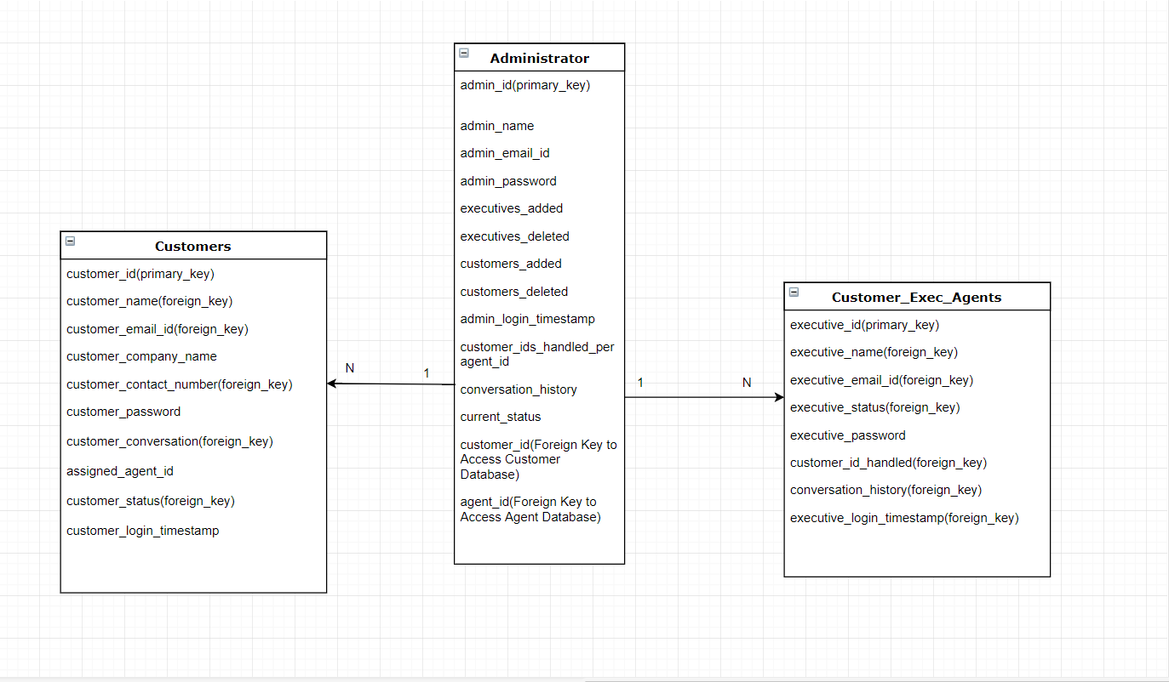
ER-Diagram of the database

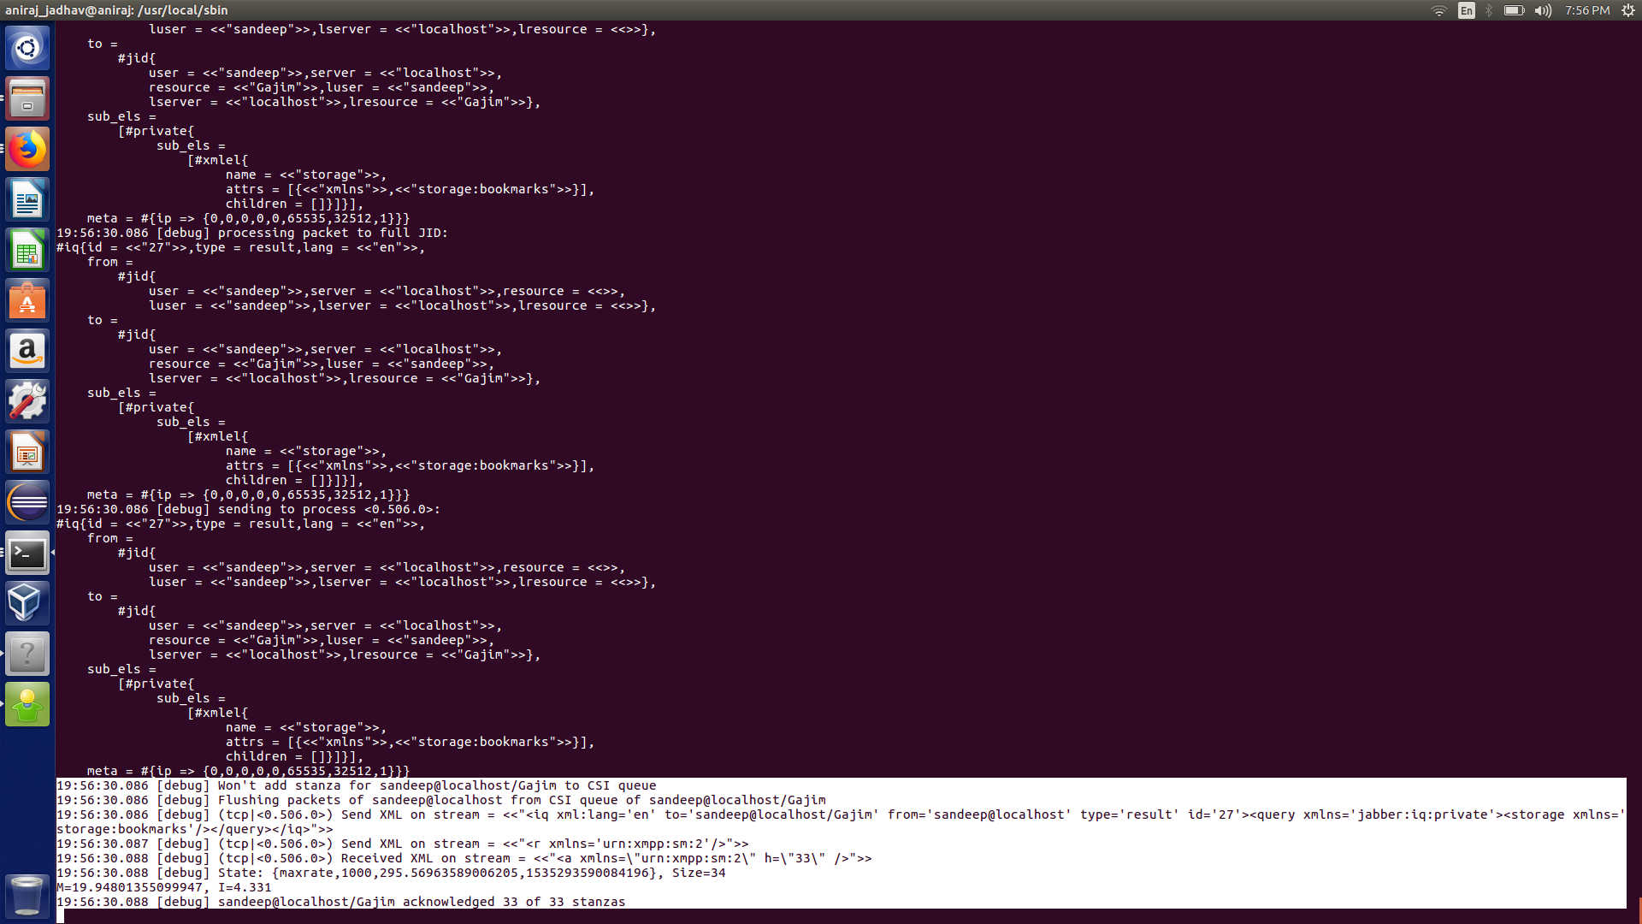
XMPP Stanzas

Ejabberd (XMPPServer)

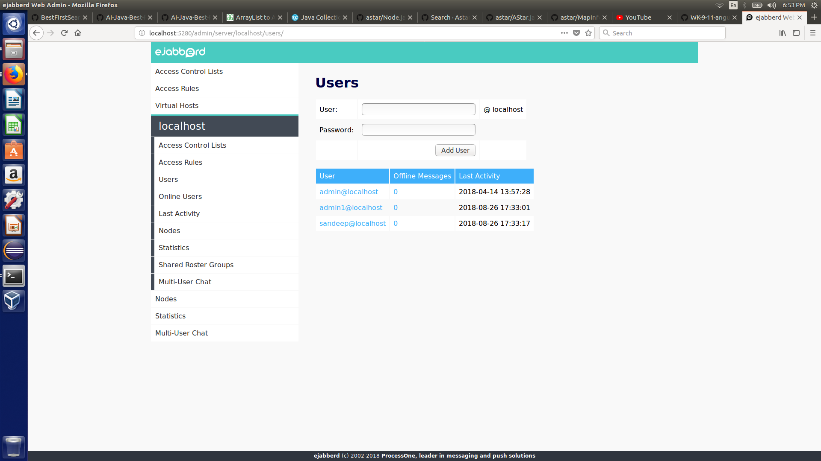

Product Function | Description | Accessibility
Login | Enter the credentials pre-approved by the company | Customers, Customer Care Executives, Administrator
Chat | Establishes an XMPP connection between the customer and the agent and pops an interactive dynamic collapsible chat widget | Customers
Chat Invitation Approval | Receive the chat invite from a customer by sensing the status of an idle agent, on acceptance, XMPP chat service will get activated and the conversation will start | Customer Care Executive, Administrator
Chat Bot Interruption | On sensing the busy status of the Customer Care Executives, an AI chat bot will attend customer inquiries | Customer
Dashboard Preview | Count of customers logged in, customer chat collapsible widget, conversation history, customer credential record, customer status, end chat, pass on to idle agent | Customer Care Executive
Dashboard Preview(Admin) | Count of customers logged in, customer chat collapsible widget, conversation history, customer credential record, customer status, end chat, pass on to idle agent, Add/Delete/Update/Create agent | Administrator

User Classes and Characteristics
The users that will be using this product should be able to use the product’s maximum potential in every way possible, that includes its secured, instant, seamless XMPP based communication service for instant messaging with no waiting time, the dashboard operation for dealing with the real time scenario such as multiple customer requests and few idle agents, which would trigger AI bot for certain customers and the idle agents will deal with their share of customers simultaneously, CRUD operations for administrator(he being the top of the hierarchy, of having maximum privileges than any other class of users).

The Customer should have the following privileges:
- Login
- Chat
- End conversation
- Logout

The Customer Care Executives (Agents) should have the following privileges:
- Login
- Chat
- Accept/Decline chat invite
- Pass the invite
- Customer credentials
- Conversation history
- End conversation
- Logout

The Administrator should have the following privileges:
- Login
- Chat
- Accept/Decline chat invite
- Pass the invite
- Customer credentials
- Conversation history
- End conversation
- CRUD agents
- View database
- Ejabberd Rest API
- Logout

Operating Environment
The Operating Environment for the chat service is as follows:

Distributed Database System for storing legitimate copies of user credentials in order to retrieve them effectively and avoid the use case of single point of failure.

Client/Server Architecture: The data resides under the server, meanwhile all the applications of the end user are executed art client side.

Database: MongoDb (Data can be stored and retrieved in json format) thus, installing and maintaining the open source database will be done with ease.

Browser: Firefox, Chrome, Safari all standard browsers will be able to conduct the web chat service frontend successfully.

Server Node: A live Computer or Server to host the XMPP based Ejabberd server in order to conduct communication streams 24/7.

Local Server: To launch the Product in Production Mode.

Design and Implementation Constraints
The web chat service will be developed in Angular 6.0 for the front-end, NodeJs for the back-end, Mongo Db for database and ultimately XMPP based server called Ejabberd for the communication paradigm.

Hosting and configuring the server in ERLANG derives the need of learning ERLANG to set up security, to enable BOSH + XMPP communication through the desired ports. Hiding the host IP and enabling a common subnet mask for the client requests.

IDE for designing the web based chat application.

Knowledge base for the AI bot that is to be conducted in offline mode. Neural Network algorithms for setting up offline response generating system.

User Documentation
Live training session will be conducted in order to walk through procedure of handling and maintaining the product.

A documentation on Ejabberd server will be handed out which can be found on the following link,

https://docs.ejabberd.im

A documentation on the product, user manual can be found on the following link,

https://github.com/anirajcr7/Web_Chat_Service

Assumptions and Dependencies
Assuming that there will be multiple customer chat invites to the limited number of Customer Care Executives, a feature to pass on the chat request to the next idle agent will be developed or the bot will be enabled for dealing with the inquiries.

To avoid single point of failure and multiple copies of the data credentials of all the users, a distributed database system is going to be held.

External Interface Requirements

  - User Interfaces

- Front-End Software: Angular 6(Ts)
- Back-End Software: NodeJs
- Database: MongoDB
- XMPP Server: Ejabberd
- Local Server: Apache Tomcat 9.0
- IDE: Microsoft Visual Studio Code

  - Hardware Interfaces

A desktop of standard office suited configuration for deploying the product is the minimum hardware requirement.

  - Software Interfaces

Software | Description
Angular 6 | Cross platform support, App like experience, front end development scripting language with a support for Typescript. Best for Animation.
NodeJs | A great back end programming scripting language for developing real time applications, that is chat apps or gaming apps. Can run on Mac OS X, Microsoft Windows, Linux and in built libraries provide an extensive list of features.
MongoDB | Document oriented storage system, thus, provides support for json file storage, highly scalable and best database for developing user data management system.
Ejabberd | An XMPP routing server best used for one to one instant messaging, multi user chatting and a robust architecture for maintaining high security.
Apache Tomcat 9.0 | Local debugging server for the product.
Microsoft Visual Studio Code | The best source code editor including a powerful tool known as IntelliSense code completion and debugging system.
Python | Scripting of offline chat bot, has the best support for machine learning libraries.
TensorFlow | Machine Learning framework, in the form of a library which eases the process of acquiring data, training models, serving predictions and refining future results.

  - Communications Interfaces

Protocol | Description
Extensible Messaging and Presence Protocol (XMPP) | A robust and powerful standard Application Layer protocol with a decentralized server architecture. Federated connections possible. Numerical priority system supports the purpose of the application.
Bi-directional streaming Over Synchronous HTTP (BOSH) | Since XMPP cannot be used over the web directly, BOSH maps the XMPP for it to be used over the browser. That is a transport binder which binds the XMPP to the TCP that is on the transport layer for real time streaming.

Product Features

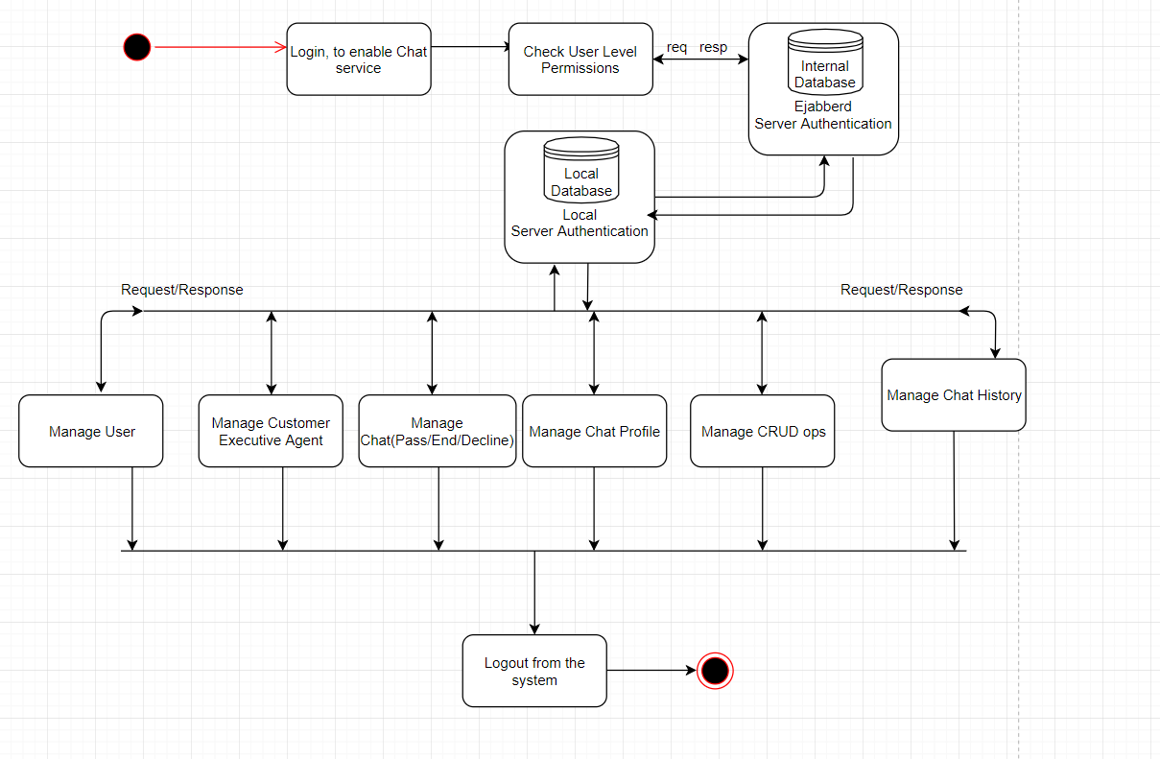
User Activity Diagram

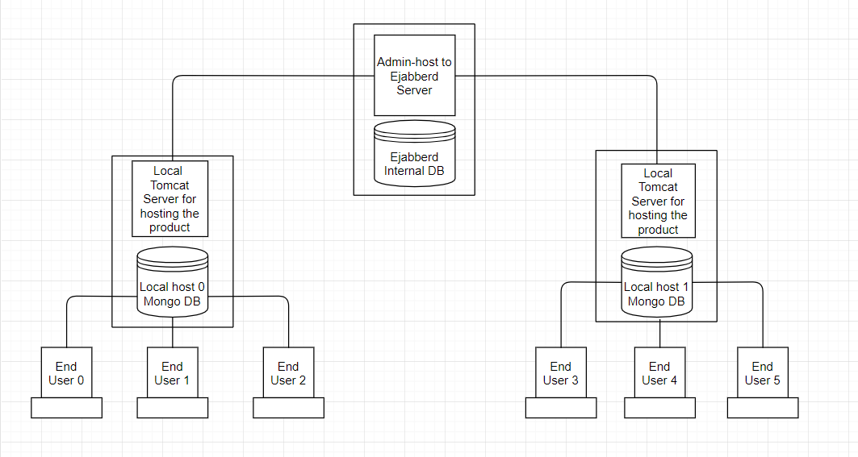
Block Diagram

USE-CASE Diagram
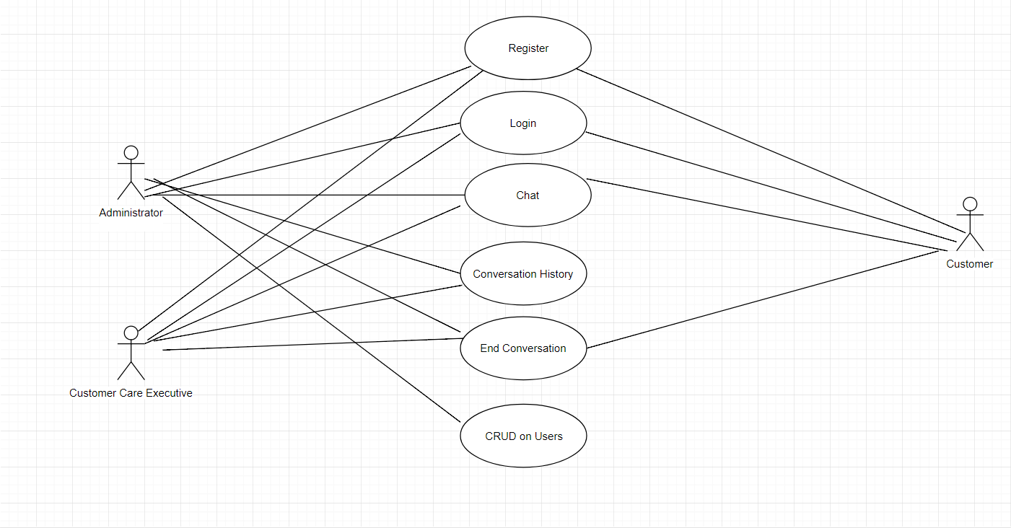

Use Cases | Description | Priority
Register with a valid account | Allows user to register with valid credentials | High
Login | Allows the user to login once the server authenticates the pre-registered user credentials | High
Start the conversation through chat service | Allows the user to enable chat service, customer to customer care executive and vice versa | High
Accept Invitation of chat service | Allows the user to grant permission to customer in order to attend customer side inquiries | High
View conversation history | Allows the user to view conversation history of different customers | Medium
CRUD operations | Allows the user to Create/Read/Update/Delete agents and/or customers | High
End Conversation | Allows the user to end the conversation once either the customer or the agent is done with their conversation | High

4.1 Specific Elaboration of Use Cases

Use Case | Register with a valid account
Description | Allows user to register with valid credentials
Actors | Customer Care Executive, Customers, Administrator
Pre-condition | User should visit the appropriate login/sign-up page for using the chat service on their computers
Post-condition | User is logged in in either of the classified accounts based on privileges, which are,  1) Customer Care Executive  2) Customers  3) Administrator
Approach | - The user (either a customer/customer care executive/administrator) visits www.Mazak.com.  - Notes the Sign-up option and fills the legitimate credentials in the sign-up form.  - Account is created.  - Enters the login credentials.  - Depending upon the back-end authentication process, the user will be directed to either Customer Care Executive page, Customer page, Administrator page.

Use Case | Start the conversation through chat service
Description | Allows the user to enable chat service, customer to customer care executive and vice versa
Actors | Customer Care Executive, Customers, Administrator
Pre-condition | User should be logged in to the concerned login page (either Customer Care Executive side, Customer side or Administrator side) to enable the chat service.
Post-condition | The customer side inquiry is dealt through real time conversation between the customer and the customer care executive
Approach | - Once the user is logged in, depending upon the type of the account, privileges will be authenticated and the following will be displayed,  Customer Care Executive Dashboard  Customer’s account with an option to enable real time chat service  Administrator’s Dashboard  - On clicking the enable chat service option, a popup widget will be triggered thus allowing the user to place their inquiries or attend the inquiries depending upon the class of users.

Use Case | Accept Invitation of chat service
Description | Allows the user to grant permission to customer in order to attend customer side inquiries
Actors | Customer Care Executive, Administrator
Pre-condition | User should be logged in to the concerned login page (either Customer Care Executive side, Administrator side) to enable the chat service.
Post-condition | The customer side inquiry is dealt through real time conversation between the customer and the customer care executive
Approach | - Once the user is logged in, depending upon the type of the account, privileges will be authenticated and the following will be displayed,  Customer Care Executive Dashboard  Administrator’s Dashboard  - The dashboard will enable the customer side chat requests to be viewed on the administrator or the customer care executive page with an option to accept the invitation or forward it to some other idle agent.

Appendix A: Glossary
XMPP – Extensible Messaging and Presence Protocol
BOSH – Bidirectional Streaming Over Synchronous HTTP
CRUD – Create, Read, Update, Delete
AI – Artificial Intelligence
ANN – Artificial Neural Network

